**Title:** Nuisance species compromise carbon sequestration potential in an Eastern US temperate deciduous forest

**Authors:**

Luca L. Morreale1,2*

Rachel M. Hoffman1

Krystal J. Bagnaschi1

Iris A. Kennedy1

Erin MacMonigle1

Caroline Troy1

Cameron Dow1,3

Erika Gonzalez-Akre1 ( Orcid ID : 0000-0001-8305-6672)

Valentine Herrmann1 ( Orcid ID : 0000-0002-4519-481X)

Jennifer Jordan1,4 ( Orcid ID : 0000-0001-5521-360X)

Lukas Magee1,5

David Mitre2

Christopher Pate1

Jessica Shue6

Norman A. Bourg1

William J. McShea1

Kristina J. Anderson-Teixeira1,2 ( Orcid ID : 0000-0001-8461-9713)

**Author Affiliations:**

1. Conservation Ecology Center, Smithsonian’s National Zoo & Conservation Biology Institute, Front Royal, Virginia 22630, USA
2. Forest Global Earth Observatory, Smithsonian Tropical Research Institute, Apartado Postal 0843-03092, Panama City, Panama
3. Department of Biology, West Virginia University, Morgantown, West Virginia 26506, USA
4. Department of Environmental Science and Public Policy, George Mason University, Fairfax, Virginia 22030, USA
5. School of Forest, Fisheries and Geomatics Sciences, University of Florida, Gainesville, Florida 32603, USA
6. Forest Global Earth Observatory, Smithsonian Environmental Research Center, Edgewater, Maryland 21037, USA

*corresponding author: [MorrealeLL@si.edu](mailto:MorrealeLL@si.edu);

**Running head:**

for submission to Anthromes joint special collection in New Phytologist/ Plants, People, Planet: <https://www.newphytologist.org/news/view/332>

*(Word limit: 6,500 words)*

# Summary

* The future of the important temperate forest carbon (C) sink is dependent on the role of nuisance species, including non-indigenous pests and pathogens and deer, yet their net effect on current and future C cycling is little understood. Here, we use 15 years of census data from a 25.6-ha plot in a Mid-Atlantic temperate forest to understand how nuisance species are affecting C sequestration.
* We analyzed biomass change and regenerative capacity in sections of the plot classified by deer browsing pressure and the abundance of species vulnerable to non-indigenous pests and pathogens.
* Biomass mortality increased, driving a net reduction in aboveground C storage, particularly in areas where canopy trees were vulnerable to non-indigenous pests and pathogens. There was also severe depletion of canopy tree species in the understory in areas with high deer browsing, endangering future canopy regeneration.
* Under current trends this forest will continue to lose living biomass and be in danger of a critical transition to a lower biomass ecosystem. This indicates that the C sequestration of U.S. Eastern deciduous forests is likely overestimated in current global carbon models, and these forests could even transition to a net source of C in the future.

**Keywords**:

*New Phytologist allows 5-8 keywords. Short phrases are acceptable*

Pests and pathogens; temperate forests; carbon sequestration; white-tailed deer; ecosystem processes; invasive species

# 1 Introduction

The temperate forest biome plays a critical role in the global carbon cycle, accounting for almost half of the net global forest carbon (C) sink (Harris *et al.*, 2021), with temperate deciduous forests alone sequestering >300 Tg C yr-1 (Pugh *et al.*, 2019). Although currently a net C sink, the future of the temperate forest biome remains uncertain. The dominant pattern projected by Earth System Models is a continued, albeit weakening, temperate forest C sink for the remainder of the 21st century (Ahlström *et al.*, 2012; Wu *et al.*, 2023). Yet, global C models predict a wide range of future trajectories of CO2 sequestration (Ahlström *et al.*, 2012; Arora *et al.*, 2020), and current global C models do not represent some influential mechanisms (e.g., Fatichi *et al.*, 2014; Clark *et al.*, 2021). For instance, one mechanism not represented in global C models is the impact of nuisance species – i.e., indigenous or non-indigenous species that, as a result of human influence, have much greater abundance in an ecosystem than they did historically, resulting in detrimental ecological consequences (Nuñez *et al.*, 2010; Skandrani *et al.*, 2014). Similarly, the impact of nuisance species on forest carbon budgets is not considered in machine learning or niche models that seek to project future forest distribution and carbon stocks, nor in carbon offset projects (Wu *et al.*, 2023). This is problematic in that nuisance species – including non-indigenous insect pests and pathogens and over-abundant herbivores – are dramatically impacting carbon cycling in temperate deciduous forests around the world.

Non-indigenous pests and pathogens can have a protracted impact on forests, often modifying forest productivity, nutrient cycling, successional trajectories, and geomorphic processes (Fischer *et al.*, 2013; Herms & McCullough, 2014; Lovett *et al.*, 2016) (Fei et al 2014). Historically introduced to new ecosystems through intercontinental trade, non-indigenous forest insects and diseases will continue to proliferate with increased globalization and human movement (Brockerhoff *et al.*, 2006; Aukema *et al.*, 2010; Fischer *et al.*, 2013). Many of the prominent pests and pathogens in temperate deciduous forests have dramatic effects on canopy composition and structure, decimating once-abundant canopy species (Aukema *et al.*, 2010; Klooster *et al.*, 2014; Ellison *et al.*, 2018; Anderson-Teixeira *et al.*, 2021). Since many pests and pathogens do not currently occupy the full extent of their host species range, a significant portion of the remaining forest canopy is susceptible to future invasion from nuisance species (Fei *et al.*, 2019), further increasing potentials for biomass loss and altered carbon cycle dynamics.

Another category of nuisance species includes mammals whose population densities have been inflated due to human activities (Clout & Russell, 2008; Murphy *et al.*, 2014), including white-tailed deer (*Odocoileus virginianus*) in U.S. eastern deciduous forests. Their populations have dramatically increased in the past 50 years (McShea *et al.*, 2003), due in large part to global change (Brown *et al.*, 2000; Rooney, 2001; Côté *et al.*, 2004). White-tailed deer preferentially browse on woody plant species in the seedling and sapling life stages, which reduces survival, growth and density (McGarvey *et al.*, 2013). Chronic white-tailed deer overabundance can reduce understory plant diversity and decrease the abundance of traditionally dominant species (Bugalho *et al.*, 2013) while giving an advantage to species they find less palatable, including both indigenous (*e.g.*, pawpaw, *Asimina tribola*; spicebush, *Lindera benzoin*) and non-indigenous (*e.g.*, garlic mustard, *Alliaria petiolata*) species (Averill *et al* 2018). The strong impact of deer browsing, exacerbated by competition with dense deer-resistant understory vegetation and possibly climate change results in dramatic reduction of canopy tree species in the understory (McGarvey *et al.*, 2013; Russell *et al.*, 2017; Miller & McGill, 2019; Gorchov *et al.*, 2021; Miller *et al.*, 2023).

In combination, increased canopy tree mortality and reduced canopy species recruitment in the understory is likely to have profound impacts on deciduous forests of eastern North America. When global change pressures (e.g., climate change, nuisance species) inhibit recruitment of canopy species, the stage is set for disturbances to push forest ecosystems over a tipping point, whereby there is little chance that a forest will recover to its pre-disturbance state in the foreseeable future (Anderson-Teixeira *et al.*, 2013; McDowell *et al.*, 2020; Turner & Seidl, 2023). In the mid-Atlantic region of the eastern United States, forests face a severe regeneration debt; there are insufficient juveniles of canopy tree species to replace the mature cohort of that species when they eventually die (Miller & McGill, 2019; Miller *et al.*, 2023). The juvenile canopy trees that are most common in contemporary mid-Atlantic forests represent a more mesophytic set of species (e.g., *Acer* spp., *Fagus grandifolia*) than historically dominated much of the region (e.g., *Quercus* spp., *Carya* spp., (Nowacki & Abrams, 2015); Thompson *et al.* 2013), but even these are often not present in sufficient abundance to replace the current canopy (Miller & McGill, 2019).

Understanding the combined effects of multiple nuisance species on forest ecosystem processes requires data on both the forest canopy and understory over an extended time. Here, we use 15 years of detailed tree census from a large forest dynamics plot the mid-Atlantic region of the eastern United States to understand the effects of non-indigenous pests and pathogens and white-tailed deer on the forest carbon balance and regeneration potential. We test the following hypotheses: (1) canopy tree mortality and associated woody biomass loss are increasing, in large part due to non-indigenous nuisance species, (2) biomass gains from tree growth and recruitment have not kept pace with tree mortality, resulting in a decline in aboveground living biomass (-∆AGB), and (3) deer browsing has decimated the abundance of canopy tree saplings, suggesting that future tree mortality will result in substantial net biomass loss and sustained decrease in the C storage potential of this ecosystem.

# 2 Materials and Methods

## 2.1 Site Description

The study was conducted in the 25.6-hectare Forest Dynamics plot at the Smithsonian’s National Zoo and Conservation Biology Institute (SCBI) in Front Royal, Virginia (38 $​^{∘}$ 53’ 36.6’‘N, 78 $​^{∘}$ 08’ 43.4’’W). The forest dynamics plot, which is located in the central Appalachian Mountains adjacent to Shenandoah National Park, is composed of mature secondary eastern deciduous forest. As part of the Appalachian Oak forest region, the canopy is dominated by tulip poplar (*Liriodendron tulipifera*), oak (*Quercus* spp.), and hickory (*Carya* spp.) and the understory is primarily composed of spicebush (*Lindera benzoin*), paw-paw (*Asimina triloba*), American hornbeam (*Carpinus caroliniana*), and witch hazel (*Hamamelis virginiana*). The land-use history of the site is varied, including periods of agricultural development and intensive logging, with dendrological data estimating canopy tree establishment around 1900 (Smithsonian Institution archives, Bourg *et al.* (2013), McGarvey *et al.* (2013)). The plot, which includes a four-hectare deer exclosure that has decreased the presence of deer since 1990, is divided into 640 quadrats, each measuring 20 x 20 meters. It is one of 78 sites in the Forest Global Earth Observatory (ForestGEO), a global network of forest dynamic plots that facilitates comparative forest ecology studies around the world (Anderson-Teixeira *et al.*, 2015; Davies *et al.*, 2021).

In addition to our consideration of the entire forest plot, we focus further on three portions of the plot, all upland forest (i.e., excluding low-lying areas around streams), with varying levels of exposure to non-indigenous insects and pathogens and white-tailed deer (Fig. 1). The first focal area we define as“Low deer, low canopy vulnerability”: A 4-ha portion of upland forest in the SE quarter of the plot (Fig. 1a), fenced in 1990 and maintained with only occasional deer presence over the past 24 years. This area has a low abundance of canopy species vulnerable to non-indigenous pests and pathogens (Holm *et al.*, 2013). The second portion is a “high deer, low canopy vulnerability” 16.3 ha upland forest area outside the deer exclosure with low abundance of canopy species affected by non-indigenous pests and pathogens (Fig. 1b). The third section of the plot has high deer, high canopy vulnerability: corresponding to 2.2 ha of upland forest outside the deer exclosure with high abundance of canopy species affected by non-indigenous pests and pathogens. We defined upland forest according to topographic wetness index, which was calculated for the forest plot by McGregor *et al.* (2021). We defined vulnerability to non-indigenous insects and pathogens based on the abundance of canopy species affected by non-indigenous pests and pathogens at the time of plot establishment (2008). The following canopy species were identified as vulnerable: ash (*Fraxinus* spp.), elm (*Ulmus* spp.), butternut (*Juglans cinerea*), and American chestnut (*Castanea dentata*) (Anderson-Teixeira *et al.*, 2021).

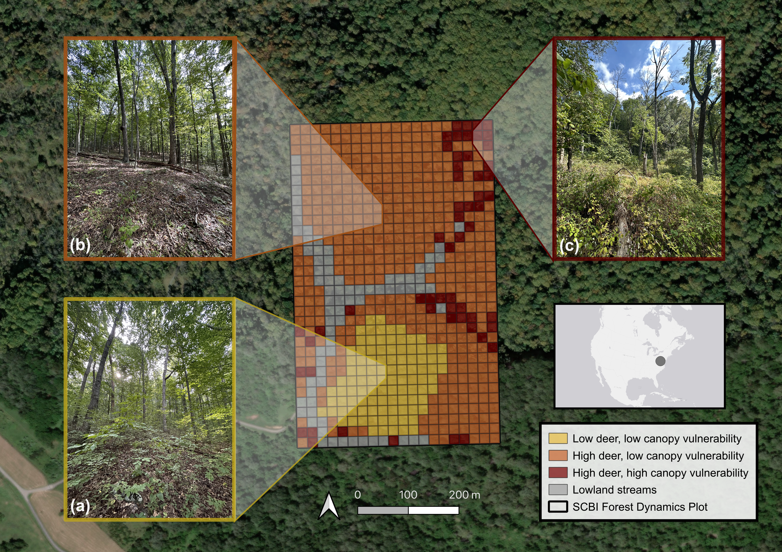

***Figure 1. Map and photos of the Forest Global Earth Observatory (ForestGEO) plot at the Smithsonian’s Conservation Biology Institute (SCBI) in Virginia, USA.*** Our analysis focuses on three portions of the plot: (a) low deer density, low abundance of canopy trees vulnerable to non-indigenous insects & pathogens, (b) high deer density, low abundance of canopy trees vulnerable to non-indigenous insects & pathogens, and (c) high deer density, high abundance of canopy trees vulnerable to non-indigenous insects & pathogens. *All photos taken September 2023 by K. Anderson-Teixeira; aerial photography from ESRI World Imagery*.

## 2.2 Data collection

As part of the ForestGEO network, the plot undergoes a comprehensive woody plant inventory every five years according to the protocol detailed in Condit (1998). This inventory, hereafter referred to as the census, includes all stems greater than one centimeter in diameter at breast height (1.3 meters; dbh). The census records the dbh, species, living status, and spatial location of each censused stem. Each individual is marked with an identifying number for sequential data collection in subsequent censuses. In multi-stemmed individuals, each additional stem that surpasses the dbh threshold receives a stem number and associated tag. The plot was established in 2008 and recensused three times (2013, 2018, 2023) since, comprising 15 years of forest dynamics data. In the last census, systematic data cleaning was continuously implemented 1) in an ESRI ArcGIS Field Maps application via built-in checks and 2) on a daily basis, via error reports generated through GitHub actions (Kim *et al.*, 2022). Each individual’s location was recorded in the Field Maps application using a digitized map of the plot (citation). In addition to the ForestGEO census, a tree health and mortality survey has been conducted annually starting in 2014 on all trees with a dbh ≥ 10 cm in the previous census (Gonzalez-Akre *et al.*, 2016). Data were collected on the current status, canopy position, percentage of crown living and intact, and visible indicators of tree health, such as physical damage, potential pathogens and insect infestation.

## 2.3 Calculating biomass dynamics and stem recruitment

We estimated total aboveground biomass (AGB) from the dbh of each stem in each census using extra-tropical allometric equations from the R package *allodb* (Gonzalez-Akre *et al.*, 2022). The *allodb* package creates species-specific allometric equations by weighting all applicable allometries within its database filtered by tree size, geography, and taxonomic information. Using the calculated stem AGB, we estimated AGB stocks at each census year for each of the plot study regions and the entire 25.6-ha plot. We quantified trends in AGB over time by calculating annualized AGB fluxes including: 1) the net change in AGB, 2) aboveground woody growth (AWG; the addition of woody biomass from tree growth), 3) aboveground woody mortality (AWM; the change of living biomass to necromass due to tree mortality), and 4) aboveground woody recruitment (AWR; the addition of living biomass through recruitment) for each census interval and plot region. We further assessed the role of nuisance species on mortality by calculating AWM flux for each year and each species using the annual mortality survey data (excluding stems < 10 cm dbh).

In addition to the estimation of AWR biomass flux, we analyzed the possible effects of nuisance species on recruitment based on counts of newly recruited stems. We categorized each species as either canopy or understory based on expert knowledge of life history traits. *Quercus* spp. and *Carya* spp. were grouped by genera to better assess differences between the recruitment of canopy and understory species. We then calculated the number of new stems for each census interval for each species or genera. Finally, we assessed the spatial overlap of biomass loss and recruitment of canopy species. We calculated the ∆AGB of canopy trees within each 0.4 hectare quadrat between 2008 and 2023 and the AGB of canopy species in the understory in 2023.

# 3 Results

Consistent with hypothesis 1, all sections of the plot experienced increased mortality (AWM) since plot establishment in 2008 (Figure 3b). The largest increases in mortality occurred in areas with the highest vulnerability to non-indigenous pests and pathogens. Initially, plot-level AWM remained constant, maintaining rates of 1.5 and 1.4 Mg C ha-1 yr-1 in the first two census intervals. However, in the most recent period, AWM increased to 3 Mg C ha-1 yr-1. Despite initial uniformity in AWM across all plot regions, high canopy vulnerability areas experienced substantial increases in AWM across all censuses, resulting in a three-fold increase in AWM from the first interval. Low canopy vulnerability regions displayed smaller rises in AWM and only in the final survey period.

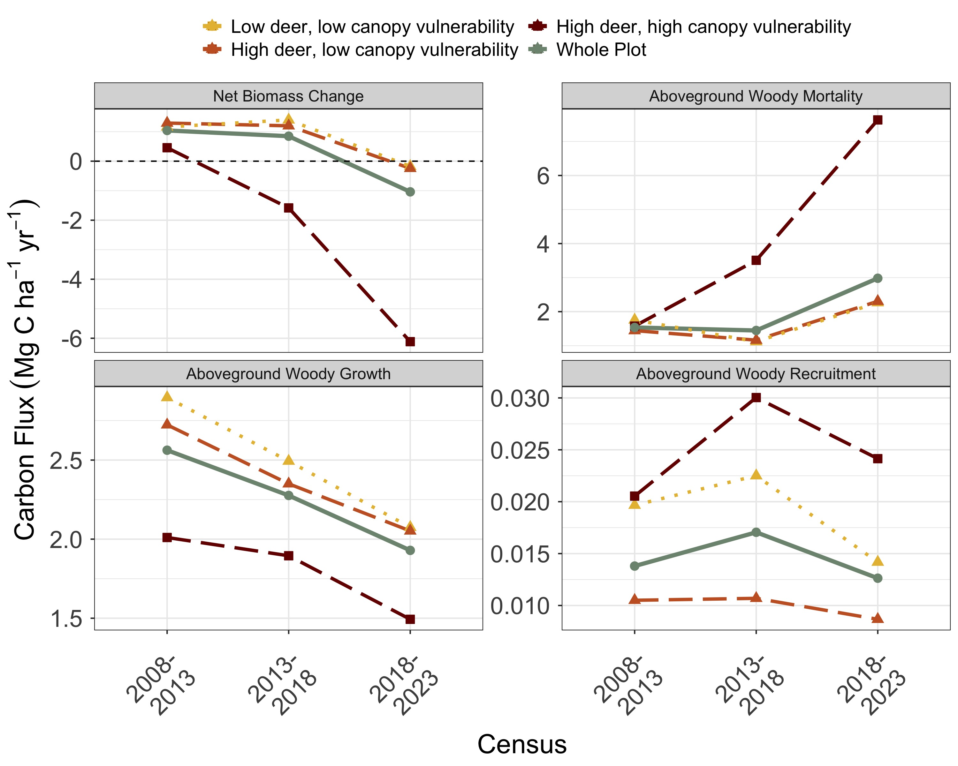

***Figure 3. Changes in aboveground woody biomass at the SCBI ForestGEO plot over each census interval since 2008 establishment, including (a) net change, (b) losses to mortality, and gains from (c) woody productivity and (d) recruitment.*** Values are shown for the plot as a whole and for regions differentiated by intensity of deer browsing and 2008 abundance of canopy tree species vulnerable to non-indigenous pests and pathogens.

Though AWM increased throughout the plot AWM rates remained stable in a majority of individual species. The increasing trend of AWM was driven primarily by two species: *Fraxinus americana* and *Quercus velutina* (Figure 4). *Fraxinus americana*, the host species for non-indigenous pest emerald ash borer (*Agrilus planipennis*), had the highest annual AWM of any species present on the plot, with an average flux of 1.6 Mg C ha-1 yr-1 and peaking at 5.3 Mg C ha-1 yr-1 in 2020. *Quercus velutina* experienced the second-highest rate of AWM at a rate of 1.0 Mg C ha-1 yr-1. The average annual AWM of these two species (2.5 Mg C ha-1 yr-1), was higher than that of all other species combined (1.8 Mg C ha-1 yr-1). Moreover, both species exhibited significant increases in AWM since the start of the census, a trend also observed in three other species in the Oak genera—*Quercus rubra*, *Quercus prinus* and *Quercus alba*.

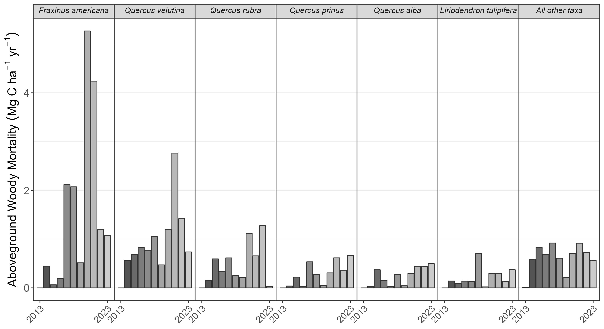

***Figure 4. Annual woody mortality by species at the SCBI ForestGEO plot from 2008-2023.*** Shown are the six canopy taxa with highest average mortality rate in descending order and a category including all others. The census included all stems ≥ 10 cm in the most recent full census.

Consistent with hypothesis 2, biomass losses to mortality outpaced biomass gains from tree growth over the 2018-23 census interval (Figure 3a). For the first time since establishment of the SCBI ForestGEO plot, living aboveground C stocks (AGB) decreased between 2018 and 2023 (Figure 2), declining from 145.9 to 140.9 Mg C ha-1. Prior to this period, AGB had consistently increased at a rate of 2.6 Mg C ha-1 yr -1 between 2008 and 2018 (Figure 3a). In regions characterized by high deer density and high canopy vulnerability, > 33% of AGB was lost over the past two censuses: dropping from 115.8 Mg C ha-1 in 2013 to 107.7 Mg C ha-1 in 2018 and then to 77 Mg C ha-1 in 2023. Conversely, areas with low density of vulnerable canopy species experienced marginal losses of AGB between 2018 and 2023; both inside and outside of the deer exclosure, biomass decreased from 154.3 to 153.3 Mg C ha-1 and 164.6 to 163.6 Mg C ha-1, respectively.

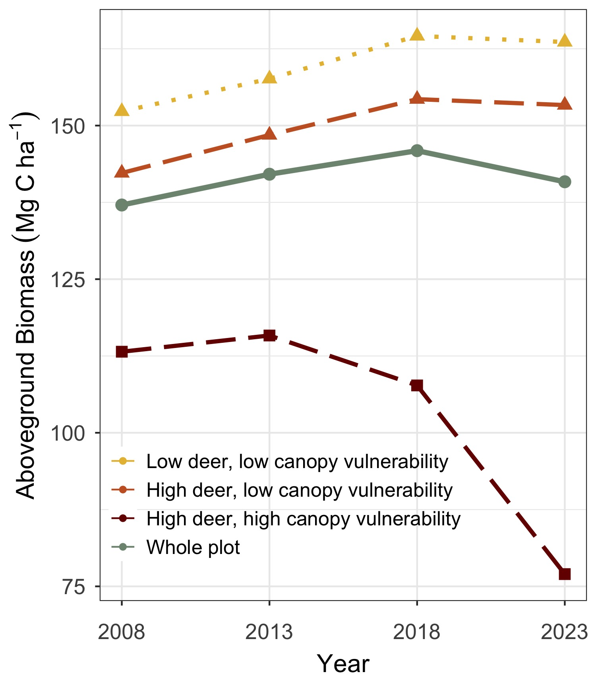

***Figure 2. Aboveground biomass at the SCBI ForestGEO plot since 2008 establishment.*** Values are shown for the plot as a whole and for regions differentiated by intensity of deer browsing and 2008 abundance of canopy tree species vulnerable to non-indigenous pests and pathogens.

Transition from net AGB accumulation to loss was not solely attributable to increased mortality; biomass accrual from woody growth (AWG) declined across all census intervals, even when AWM did not increase (Figure 3c). Plot-wide AWG decreased by -30 %, from 2.6 Mg C ha-1 yr-1 over 2008-2013 to 1.9 Mg C ha-1 yr-1 in the 2018-2023 interval. Areas with low canopy vulnerability consistently displayed the highest AWG (2.1 Mg C ha-1 yr-1 in the 2018-2023 period), while the AWG in the portion with high canopy vulnerability was significantly lower (1.5Mg C ha-1 yr-1). Woody recruitment flux (AWR), constituting a minor fraction of net biomass change, showed no significant temporal trend (Figure 3d). AWR consistently remained lowest in areas characterized by high deer density and low canopy vulnerability, whereas it reached its highest levels in regions with high canopy vulnerability, recording rates of 0.01 Mg C ha-1 yr-1 and 0.025 Mg C ha-1 yr-1, respectively.

Consistent with hypotehsis 3, deer density had strong mediating effects on the composition of woody stem recruitment (Figure 5). The region characterized by low deer density exhibited significantly higher annual recruitment of canopy taxa compared to those areas with higher deer density— specifically, 38.7 stems ha-1 yr-1 compared to 19 ha-1 yr-1. In particular, the recruitment rate of *Carya* spp. and *Quercus* spp., late-successional taxa characteristic of this forest’s expected climax state, was reduced by > 50% in areas with high deer density. The prevalence of vulnerable canopy species in regions with low deer density showed no significant impact on the total quantity of canopy species recruitment into the understory. However, recruitment of *Fraxinus americana* and *Fagus grandifolia* was higher in areas with high canopy vulnerability, while recruitment of *Ulmus rubra* and *Carya* spp. was lower. Across all regions, the recruitment rate of understory taxa was nearly 10 times that of canopy taxa. Recruitment of *Lindera benzoin* was high across all regions (> 100 stems ha-1 yr-1), and significantly increased in areas with high deer densities while peaking in areas that also had low canopy vulnerability. *Asimina triloba* recruitment was also lowest within the deer exclosure (18.6 stems ha-1 yr-1) but was highest in the region with high deer density and high canopy vulnerability (76.6 stems ha-1 yr-1).

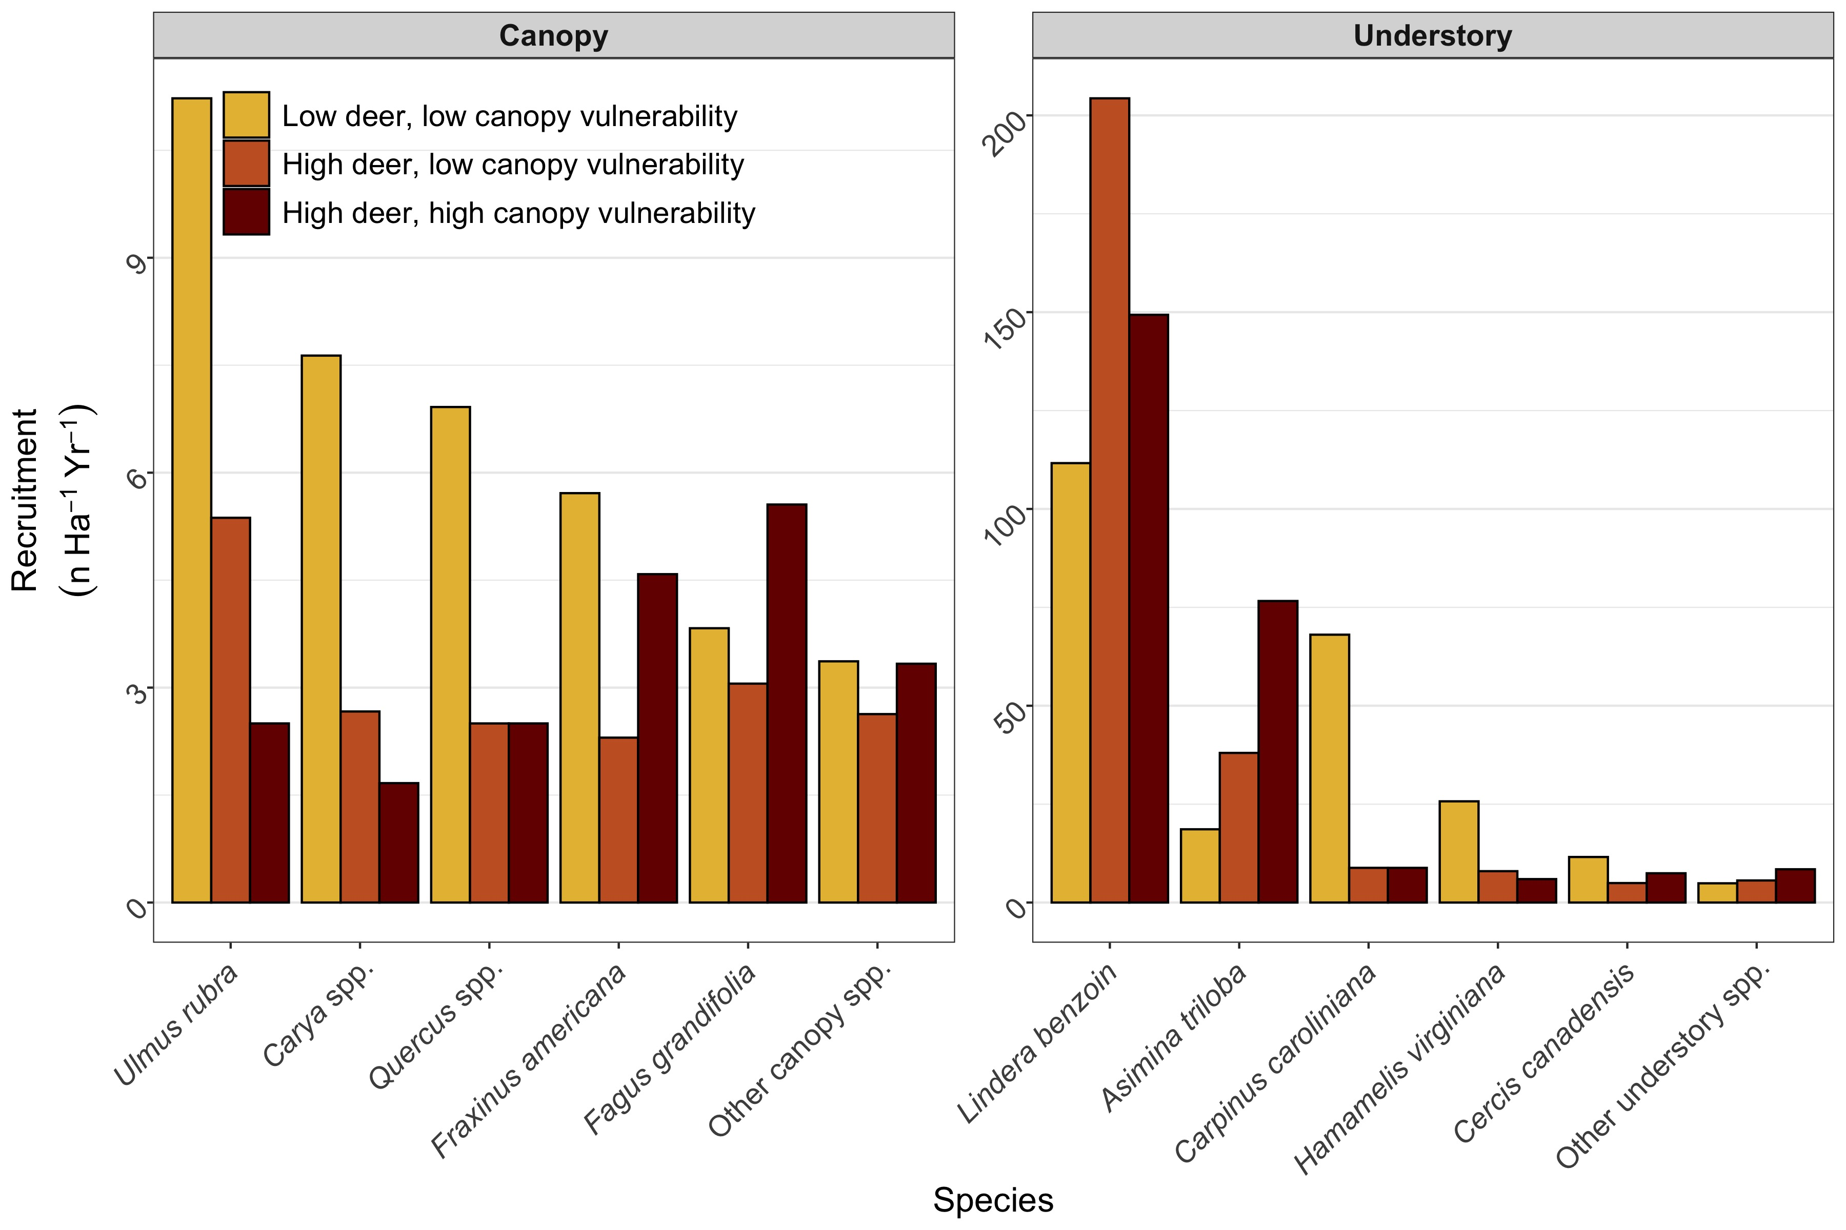

***Figure 5. Average annual recruitment (2008-2023) of canopy and understory tree species at the SCBI ForestGEO plot across areas differentiated by intensity of deer browsing and 2008 abundance of canopy tree species vulnerable to non-indigenous pests and pathogens.*** Note that y-axes differ, with understory species recruitment > 20x that of canopy species recruitment.

There were significant areas of suppressed regeneration of canopy species, often coincident with decreasing AGB. Only 21.7% of the plot (mostly inside the deer exlosure) exhibited an understory with high AGB of species capable of reaching the canopy. Within the plot areas characterized by high deer density and high canopy vulnerability, 84% of the area had lost canopy biomass, only 5.4% had an understory containing high AGB of canopy taxa, and 0% of area exhibited both a healthy understory and increasing AGB. In contrast, 70.7% of the plot area with low deer density and low canopy vulnerability had high AGB of canopy species in the understory, indicating a higher likelihood of future C sequestration. Furthermore, 72.7% of the region with low deer density and low canopy vulnerability had a net increase of AGB.

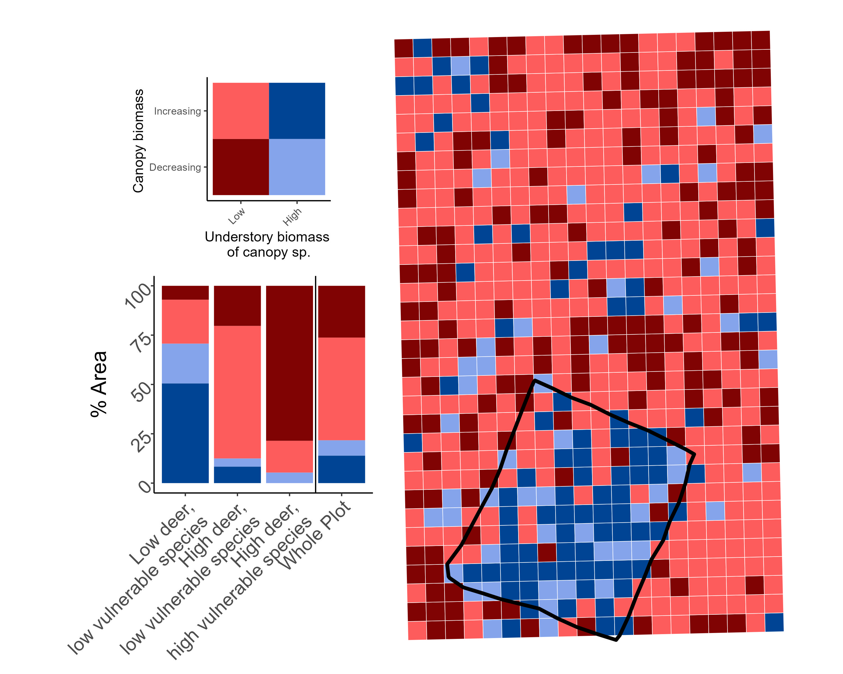

***Figure 6. Map of changes in canopy biomass (2008-2023) and the biomass of canopy taxa in the understory in 2023 within the SCBI ForestGEO plot.*** (a) Each .04 ha quadrat is classified by the ∆AGB of canopy trees over the 15-year study period and the AGB of canopy taxa in the understory in 2023. (b) The % area of each region that falls within each classification.

# 4 Discussion

The combination of -∆AGB and limited recruitment of canopy species in the understory is compromising the potential carbon sink of this forest, now and into the future. Decreases in AGB were largest in the regions of the plot with high canopy vulnerability to pests and pathogens. These regions also exhibited the lowest recruitment of canopy species in the understory. Deer severely depleted regeneration of canopy species and the region with low deer density maintained the highest amount of canopy species in the understory. Despite localized increases in AGB, notably in areas with low canopy vulnerability, on net, these increases are not outpacing AGB lost through a combination of increased AWM and decreasing AWG. Total ABG stocks in the plot were lower in 2023 than in 2013. Moreover, the low recruitment of canopy species in areas with high canopy vulnerability suggests that heavy deer browsing on canopy species may be exacerbated in areas with canopy openings due to nuisance-species driven mortality where fast-growing understory species that are resistant to deer can take advantage, further competing with canopy recruitment.

While nuisance species have had a large impact on AGB loss at our site (primarily through increased AWM of *Fraxinus americana*; Anderson-Teixeira et al, 2021), mortality among oak species, which is not linked to a non-indigenous nuisance species, is substantial as well. Oak species in the region are generally found in older, even aged cohorts, which can contribute to accelerated mortality rates (Oak et al., 2016). However, large oak mortality events, which often occur over protracted periods of time, have been common globally over the past century. These mortality events are often termed “oak decline” events due to the complex abiotic and biotic factors which interact to incite mortality (Manion and Lachance, 1992). Oak decline is believed to be the result of an imbalance in carbohydrate dynamics, which weakens oak trees’ resistance to pest and pathogen invasion, eventually leading to mortality (Manion and Lachance, 1992).

Relying on the current understory as a proxy for future canopy presents challenges. White-tailed deer populations have varied greatly over the last century (citation). Moreover, some canopy species, including some *Quercus* spp., are hypothesized to recruit in synchronized pulse events (Koenig, 2021). A decline in deer population that reduces browsing pressure and coincides with a recruitment pulse, could allow for substantial, rapid regeneration of canopy species. However, current recruitment levels are below a rate which we would expect in maturing secondary forests. When overlaid with increasing mortality, regeneration may be insufficient to prevent extended periods without a closed canopy.

Despite inherent limitations in extrapolating findings from a single site, we find robust evidence suggesting broader applicability. Mixed-hardwood forests, akin to our study site, are typical of the mid-Atlantic region. The persistently elevated deer populations documented at this site are reported throughout eastern US forests. Furthermore,the widespread occurrence of vulnerable species (*e.g.* *Fraxinus* spp.) and continued spread of non-indigenous nuisance species (*e.g.* emerald ash borer, EAB) reinforces the relevance of our findings to the broader regional context. EAB consistently induces near-total mortality in *Fraxinus* spp. once infected, to such an extent that five species in North America (including *Fraxinus americana*) are now critically endangered (Knight et al, 2013, IUCN Red list).

Our results underscore the importance of accounting for nuisance species in higher-level models and understanding of temperate forest ecosystem processes. Nuisance species, driven by human introduction and perturbations to ecological equilibriums, interact with other anthropogenic changes to modify forest ecosystems. By increasing mortality, nuisance species have the capacity to alter short-term carbon dynamics, resulting in large carbon losses that would not be expected in models that exclude them. Through recruitment suppression, nuisance species can have long-term effects that may alter successional dynamics. They can delay recovery from disturbances, anthropogenic or natural, and even suppress regeneration into a closed-canopy for sustained periods. They also can decrease resilience to other pressures as pests and pathogens decrease canopy diversity by shrinking the number of possible canopy species.

Nuisance species pose a serious threat to the health of temperate forests. But, this work highlights the potential of active management to protect them. Increased understory recruitment within the deer exclosure demonstrates that lowering deer populations can reduce browsing pressure. The direct linkage between non-indigenous pests and pathogens and decreased carbon storage demonstrates the need for natural climate solutions that focus on preserving the forests that we have instead of planting new ones. Opportunities exist to expand efforts that prevent further spread, increase the application of extant treatments, and continue research into natural immunity.

# 5 Future Directions

Understanding interactions between global change drivers, an ongoing area of research, is critical. We would expect that trees unaffected by nuisance species (*e.g.* *Liriodendron tulipifera*, *Quercus rubra*) might see productivity increases as canopy gaps form and competition from nearby trees decreases. However, continuous decreases in AWG throughout the plot suggests that other mechanisms, including increasing maximum temperatures during the growing season (Dow et al 2022), may be hindering tree growth. Tree seedlings of many species, already decimated by deer browsing, are further threatened by rising maximum temperatures (McEwan et al 2011). Increasing mortality within *Quercus* species is another focal area of future research, as species within the *Quercus* genera constitute > 33% of woody productivity at this site (McGregor et al 2020). Multiple global changes already impact the SCBI ForestGEO plot; carbon storage in the site is, and will be, mediated by multifaceted, interacting pressures resulting from human actions.

Future research should build on our results by expanding these analyses to other temperate forest regions. While other areas will have different forest compositions and herbivory dynamics, increasing pressure from pests and pathogens is pervasive throughout temperate forests (Santini et al. 2012, Ayres and Lombardero 2018). Moreover, while not a large factor at this site, the spread of non-indigenous plant species can further threaten the regeneration of woody canopy species (Pile Knapp et al, 2023). Large forest dynamics sites (*i.e.* other sites in the ForestGEO network) are well-suited to this research and can be leveraged to quantify how nuisance species compromise present and future forest carbon sequestration. Expanding the scale of these analyses may also facilitate the incorporation of nuisance species into global vegetation and carbon models. Future evaluations of temperate forest health and carbon storage must account for the substantial effects of nuisance species along with other global changes.

# Acknowledgements

We gratefully acknowledge the many researchers who have collected data at the SCBI ForestGEO plot over the years. This research was funded by Smithsonian’s Forest Global Earth Observatory, Smithsonian’s National Zoo and Conservation Biology Institute, NSF Macrosystems grant #2106015, and grants from Virginia Native Plants Society and Shenandoah National Park Trust.

# Competing Interests

The authors declare no conflict of interest.

# Author Contributions

LLM, RMH, KJB, IAK, EM, CT, DM, JS, NAB, WJM, and KAT conceived the ideas and designed methodology; all researchers contributed to data collection; LLM, RH, KJB, IAK, EM and VH analyzed the data; LLM and RMH led the writing of the manuscript. All authors contributed critically to the drafts and gave final approval for publication.

# Data and code availability

All data and code supporting this analysis are available via the public GitHub repository “15yrsChange” within the SCBI-ForestGEO organization (<https://github.com/SCBI-ForestGEO/15yrsChange>) and archived in Zenodo (DOI: TBD). The most up-to-date versions of the data products analyzed here are publicly available via the ForestGEO data portal (<https://forestgeo.si.edu/explore-data>) and the SCBI-ForestGEO GitHub organization (<https://github.com/SCBI-ForestGEO>).

# References

**Ahlström A, Schurgers G, Arneth A, Smith B**. **2012**. [Robustness and uncertainty in terrestrial ecosystem carbon response to CMIP5 climate change projections](https://doi.org/10.1088/1748-9326/7/4/044008). *Environmental Research Letters* **7**: 044008.

**Anderson-Teixeira KJ, Davies SJ, Bennett AC, Gonzalez-Akre EB, Muller-Landau HC, Joseph Wright S, Abu Salim K, Almeyda Zambrano AM, Alonso A, Baltzer JL, *et al.*** **2015**. [CTFS-ForestGEO: A worldwide network monitoring forests in an era of global change](https://doi.org/10.1111/gcb.12712). *Global Change Biology* **21**: 528–549.

**Anderson-Teixeira KJ, Herrmann V, Cass WB, Williams AB, Paull SJ, Gonzalez-Akre EB, Helcoski R, Tepley AJ, Bourg NA, Cosma CT, *et al.*** **2021**. [Long-Term Impacts of Invasive Insects and Pathogens on Composition, Biomass, and Diversity of Forests in Virginia’s Blue Ridge Mountains](https://doi.org/10.1007/s10021-020-00503-w). *Ecosystems* **24**: 89–105.

**Anderson-Teixeira KJ, Miller AD, Mohan JE, Hudiburg TW, Duval BD, DeLucia EH**. **2013**. [Altered dynamics of forest recovery under a changing climate](https://doi.org/10.1111/gcb.12194). *Global Change Biology* **19**: 2001–2021.

**Arora VK, Katavouta A, Williams RG, Jones CD, Brovkin V, Friedlingstein P, Schwinger J, Bopp L, Boucher O, Cadule P, *et al.*** **2020**. [Carbon– concentration and carbon– climate feedbacks in CMIP6 models and their comparison to CMIP5 models](https://doi.org/10.5194/bg-17-4173-2020). *Biogeosciences (Online)* **17**: 4173–4222.

**Aukema JE, McCullough DG, Holle BV, Liebhold AM, Britton K, Frankel SJ**. **2010**. [Historical Accumulation of Nonindigenous Forest Pests in the Continental United States](https://doi.org/10.1525/bio.2010.60.11.5). *BioScience 60(11):886-897. 2010* **60**: 886–897.

**Bourg N, McShea W, Thompson J, McGarvey J, Shen X**. **2013**. [Initial census, woody seedling, seed rain, and stand structure data for the SCBI SIGEO Large Forest Dynamics Plot](https://doi.org/10.1890/13-0010.1). *Ecology* **94**: 2111–2112.

**Brockerhoff EG, Liebhold AM, Jactel H**. **2006**. [The ecology of forest insect invasions and advances in their management](https://doi.org/10.1139/x06-013). *Canadian Journal of Forest Research 36:263-268* **36**.

**Brown TL, Decker DJ, Riley SJ, Enck JW, Lauber TB, Curtis PD, Mattfeld GF**. **2000**. [The Future of Hunting as a Mechanism to Control White-Tailed Deer Populations](https://www.jstor.org/stable/3783834). *Wildlife Society Bulletin (1973-2006)* **28**: 797–807.

**Bugalho MN, Ibáñez I, Clark JS**. **2013**. [The effects of deer herbivory and forest type on tree recruitment vary with plant growth stage](https://doi.org/10.1016/j.foreco.2013.07.036). *Forest Ecology and Management* **308**: 90–100.

**Clark JS, Andrus R, Aubry-Kientz M, Bergeron Y, Bogdziewicz M, Bragg DC, Brockway D, Cleavitt NL, Cohen S, Courbaud B, *et al.*** **2021**. [Continent-wide tree fecundity driven by indirect climate effects](https://doi.org/10.1038/s41467-020-20836-3). *Nature Communications* **12**: 1242.

**Clout MN, Russell JC**. **2008**. [The invasion ecology of mammals: A global perspective](https://doi.org/10.1071/WR07091). *Wildlife Research* **35**: 180–184.

**Condit R**. **1998**. [*Tropical Forest Census Plots: Methods and Results from Barro Colorado Island, Panama and a Comparison with Other Plots*](https://doi.org/10.1007/978-3-662-03664-8). Berlin, Heidelberg: Springer.

**Côté SD, Rooney TP, Tremblay J-P, Dussault C, Waller DM**. **2004**. [Ecological Impacts of Deer Overabundance](https://www.jstor.org/stable/30034112). *Annual Review of Ecology, Evolution, and Systematics* **35**: 113–147.

**Davies SJ, Abiem I, Abu Salim K, Aguilar S, Allen D, Alonso A, Anderson-Teixeira K, Andrade A, Arellano G, Ashton PS, *et al.*** **2021**. [ForestGEO: Understanding forest diversity and dynamics through a global observatory network](https://doi.org/10.1016/j.biocon.2020.108907). *Biological Conservation* **253**: 108907.

**Ellison AM, Orwig DA, Fitzpatrick MC, Preisser EL**. **2018**. [The Past, Present, and Future of the Hemlock Woolly Adelgid (Adelges tsugae) and Its Ecological Interactions with Eastern Hemlock (Tsuga canadensis) Forests](https://doi.org/10.3390/insects9040172). *Insects* **9**: 172.

**Fatichi S, Leuzinger S, Körner C**. **2014**. Moving beyond photosynthesis: From carbon source to sink-driven vegetation modeling. *The New Phytologist* **201**: 1086–1095.

**Fei S, Morin RS, Oswalt CM, Liebhold AM**. **2019**. [Biomass losses resulting from insect and disease invasions in US forests](https://doi.org/10.1073/pnas.1820601116). *Proceedings of the National Academy of Sciences* **116**: 17371–17376.

**Fischer A, Marshall P, Camp A**. **2013**. [Disturbances in deciduous temperate forest ecosystems of the northern hemisphere: Their effects on both recent and future forest development](https://doi.org/10.1007/s10531-013-0525-1). *Biodiversity and Conservation* **22**: 1863–1893.

**Gonzalez-Akre E, Meakem V, Eng C-Y, Tepley AJ, Bourg NA, McShea W, Davies SJ, Anderson-Teixeira K**. **2016**. [Patterns of tree mortality in a temperate deciduous forest derived from a large forest dynamics plot](https://doi.org/10.1002/ecs2.1595). *Ecosphere (Washington, D.C)* **7**: n/a–n/a.

**Gonzalez-Akre E, Piponiot C, Lepore M, Herrmann V, Lutz JA, Baltzer JL, Dick CW, Gilbert GS, He F, Heym M, *et al.*** **2022**. [Allodb: An R package for biomass estimation at globally distributed extratropical forest plots](https://doi.org/10.1111/2041-210X.13756). *Methods in Ecology and Evolution* **13**: 330–338.

**Gorchov DL, Blossey B, Averill KM, Dávalos A, Heberling JM, Jenkins MA, Kalisz S, McShea WJ, Morrison JA, Nuzzo V, *et al.*** **2021**. [Differential and interacting impacts of invasive plants and white-tailed deer in eastern U.S. forests](https://doi.org/10.1007/s10530-021-02551-2). *Biological Invasions* **23**: 2711–2727.

**Harris NL, Gibbs DA, Baccini A, Birdsey RA, de Bruin S, Farina M, Fatoyinbo L, Hansen MC, Herold M, Houghton RA, *et al.*** **2021**. [Global maps of twenty-first century forest carbon fluxes](https://doi.org/10.1038/s41558-020-00976-6). *Nature Climate Change*: 1–7.

**Herms DA, McCullough DG**. **2014**. [Emerald ash borer invasion of North America: History, biology, ecology, impacts, and management](https://doi.org/10.1146/annurev-ento-011613-162051). *Annual Review of Entomology* **59**: 13–30.

**Holm JA, Thompson JR, McShea WJ, Bourg NA**. **2013**. [Interactive effects of chronic deer browsing and canopy gap disturbance on forest successional dynamics](https://doi.org/10.1890/ES13-00223.1). *Ecosphere* **4**: 1–23.

**Kim AY, Herrmann V, Barreto R, Calkins B, Gonzalez-Akre E, Johnson DJ, Jordan JA, Magee L, McGregor IR, Montero N, *et al.*** **2022**. [Implementing GitHub Actions continuous integration to reduce error rates in ecological data collection](https://doi.org/10.1111/2041-210X.13982). *Methods in Ecology and Evolution* **13**: 2572–2585.

**Klooster WS, Herms DA, Knight KS, Herms CP, McCullough DG, Smith A, Gandhi KJK, Cardina J**. **2014**. [Ash (Fraxinus spp.) Mortality, regeneration, and seed bank dynamics in mixed hardwood forests following invasion by emerald ash borer (Agrilus planipennis)](https://doi.org/10.1007/s10530-013-0543-7). *Biological Invasions* **16**: 859–873.

**Lovett GM, Weiss M, Liebhold AM, Holmes TP, Leung B, Lambert KF, Orwig DA, Campbell FT, Rosenthal J, McCullough DG, *et al.*** **2016**. [Nonnative forest insects and pathogens in the United States: Impacts and policy options](https://doi.org/10.1890/15-1176). *Ecological Applications* **26**: 1437–1455.

**McDowell NG, Allen CD, Anderson-Teixeira K, Aukema BH, Bond-Lamberty B, Chini L, Clark JS, Dietze M, Grossiord C, Hanbury-Brown A, *et al.*** **2020**. [Pervasive shifts in forest dynamics in a changing world](https://doi.org/10.1126/science.aaz9463). *Science (New York, N.Y.)* **368**.

**McGarvey JC, Bourg NA, Thompson JR, McShea WJ, Shen X**. **2013**. [Effects of Twenty Years of Deer Exclusion on Woody Vegetation at Three Life-History Stages in a Mid-Atlantic Temperate Deciduous Forest](https://doi.org/10.1656/045.020.0301). *Northeastern Naturalist* **20**: 451–468.

**McGregor IR, Helcoski R, Kunert N, Tepley AJ, Gonzalez-Akre EB, Herrmann V, Zailaa J, Stovall AEL, Bourg NA, McShea WJ, *et al.*** **2021**. [Tree height and leaf drought tolerance traits shape growth responses across droughts in a temperate broadleaf forest](https://doi.org/10.1111/nph.16996). *New Phytologist* **231**: 601–616.

**McShea WJ, Underwood HB, Rappole JH**. **2003**. *The Science of Overabundance: Deer Ecology and Population Management*. Smithsonian.

**Miller KM, McGill BJ**. **2019**. [Compounding human stressors cause major regeneration debt in over half of eastern US forests](https://doi.org/10.1111/1365-2664.13375). *Journal of Applied Ecology* **56**: 1355–1366.

**Miller KM, Perles SJ, Schmit JP, Matthews ER, Weed AS, Comiskey JA, Marshall MR, Nelson P, Fisichelli NA**. **2023**. [Overabundant deer and invasive plants drive widespread regeneration debt in eastern United States national parks](https://doi.org/10.1002/eap.2837). *Ecological Applications* **33**: e2837.

**Murphy MJ, Inman-Narahari F, Ostertag R, Litton CM**. **2014**. [Invasive feral pigs impact native tree ferns and woody seedlings in Hawaiian forest](https://doi.org/10.1007/s10530-013-0503-2). *Biological Invasions* **16**: 63–71.

**Nowacki GJ, Abrams MD**. **2015**. [Is climate an important driver of post-European vegetation change in the Eastern United States?](https://doi.org/10.1111/gcb.12663) *Global Change Biology* **21**: 314–334.

**Nuñez MA, Bailey JK, Schweitzer JA**. **2010**. [Population, community and ecosystem effects of exotic herbivores: A growing global concern](https://doi.org/10.1007/s10530-009-9626-x). *Biological Invasions* **12**: 297–301.

**Pugh TAM, Lindeskog M, Smith B, Poulter B, Arneth A, Haverd V, Calle L**. **2019**. [Role of forest regrowth in global carbon sink dynamics](https://doi.org/10.1073/pnas.1810512116). *Proceedings of the National Academy of Sciences* **116**: 4382–4387.

**Rooney TP**. **2001**. [Deer impacts on forest ecosystems: A North American perspective](https://doi.org/10.1093/forestry/74.3.201). *Forestry: An International Journal of Forest Research* **74**: 201–208.

**Russell MB, Woodall CW, Potter KM, Walters BF, Domke GM, Oswalt CM**. **2017**. [Interactions between white-tailed deer density and the composition of forest understories in the northern United States](https://doi.org/10.1016/j.foreco.2016.10.038). *Forest Ecology and Management* **384**: 26–33.

**Skandrani Z, Lepetz S, Prévot-Julliard A-C**. **2014**. [Nuisance species: Beyond the ecological perspective](https://doi.org/10.1186/2192-1709-3-3). *Ecological Processes* **3**: 3.

**Turner MG, Seidl R**. **2023**. [Novel Disturbance Regimes and Ecological Responses](https://doi.org/10.1146/annurev-ecolsys-110421-101120). *Annual Review of Ecology, Evolution and Systematics* **54**: 63–83.

**Wu C, Coffield SR, Goulden ML, Randerson JT, Trugman AT, Anderegg WRL**. **2023**. [Uncertainty in US forest carbon storage potential due to climate risks](https://doi.org/10.1038/s41561-023-01166-7). *Nature Geoscience*: 1–8.